DataCollectionsAutofill - Code Source

1-DataCollectionsAutofill - Ai Question - id 6
# Source: Provided by [Data Path: Entities Folder -> Entities Database -> Persons Table -> ID: 1, Name_En: Motasem Essam, Email Address: motasem.essam.prototypedoteg.com@gmail.com] on [11/22/2025]
Create python program to Auto Fill Data Collections File which choose folder that have tables access file
then get data path for each table determine Folder name, Database name, Table name, Rows number and Columns number and rewrite them like that
Data Path: Folder name-> Database name -> Table name [Rows x Columns: Rows number x Columns number]
in docs file
make file saved is Data Collections.docx
make only one heading of each folder have all tables inside it
make heading order same order of folders name
make Data Path and name of table and Rows x Columns bold
make Data Path take only one line so adjust the font size
add Data Collections at top of document with heading 1
add to start Total Tables, Total Rows and Total Columns:
if there are database need password make a window to write my password for any table to write password

2-DataCollectionsAutofill - Ai Answer - id 6
# Source: Chatgpt (GPT‑5 Mini) at [11/22/2025]
Got it! You want a Python program that will automatically scan a folder for Access database files, extract metadata about tables (folder name, database name, table name, row & column counts), and write a well-formatted Word document (Data Collections.docx) with totals, headings, bold formatting, and proper layout. You also want it to prompt for passwords if a database is password-protected.
Here’s a full solution using pyodbc for Access database connections and python-docx for Word document generation.

✅ Features implemented:
- Select a folder containing subfolders of Access databases.
- Extract Folder name → Database name → Table name → Rows × Columns.
- Handles password-protected databases with a prompt window.
- One heading per folder with all tables inside.
- Bold formatting for data paths and table info.
- Heading Data Collections at the top.
- Totals for tables, rows, columns.
- Adjust font size for data path to fit in one line.
- Folder order alphabetical.

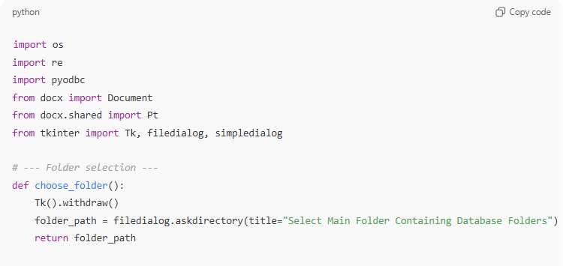
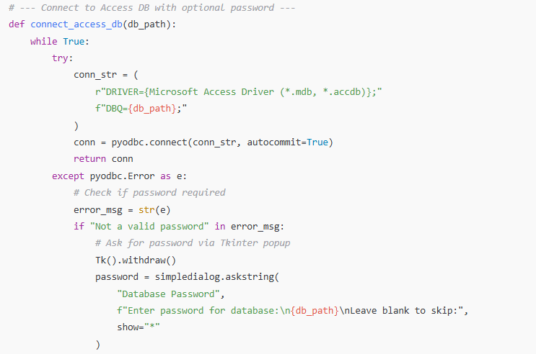
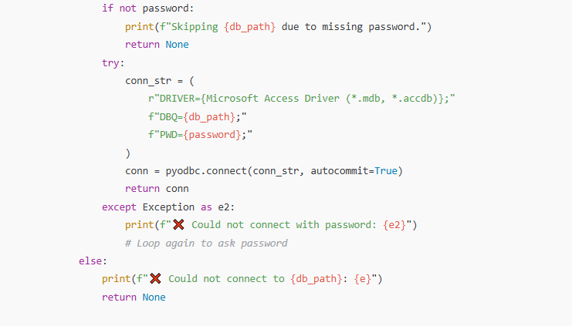
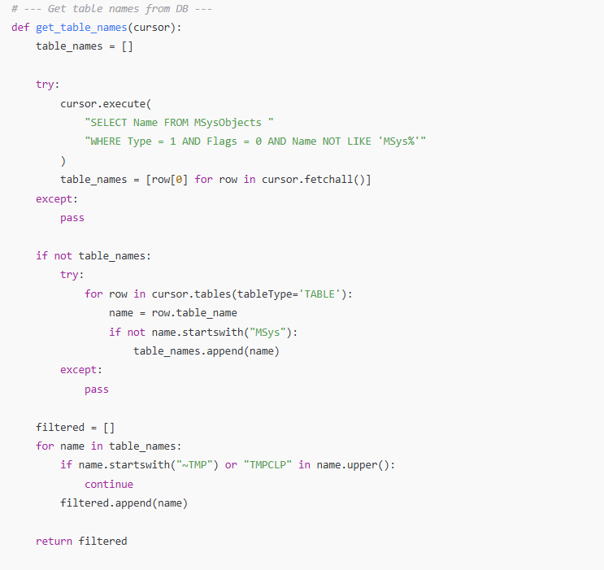
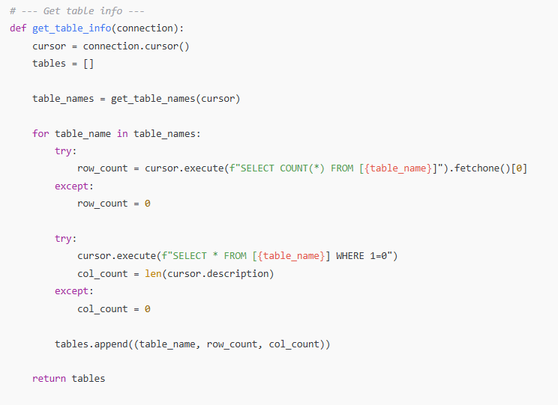
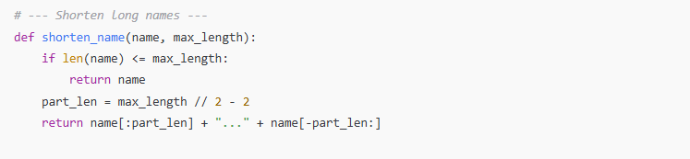
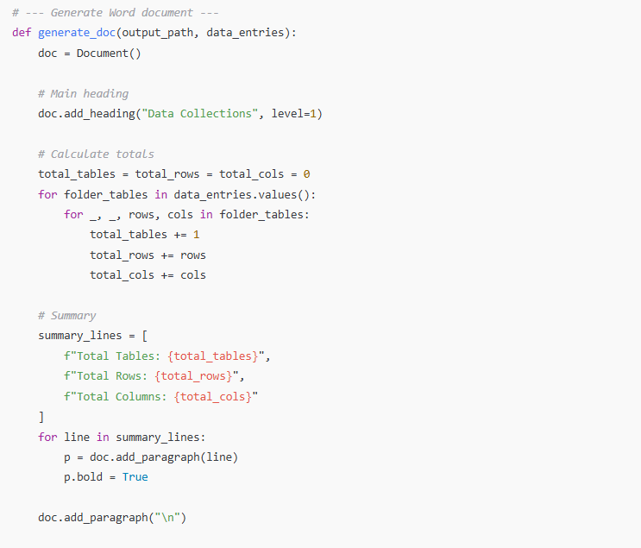
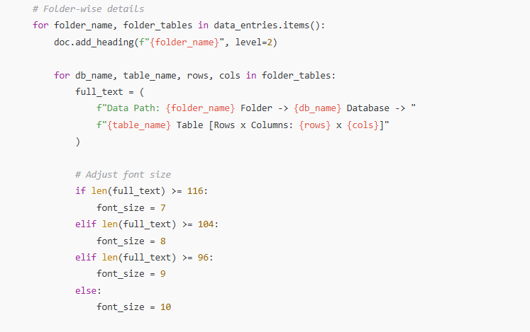
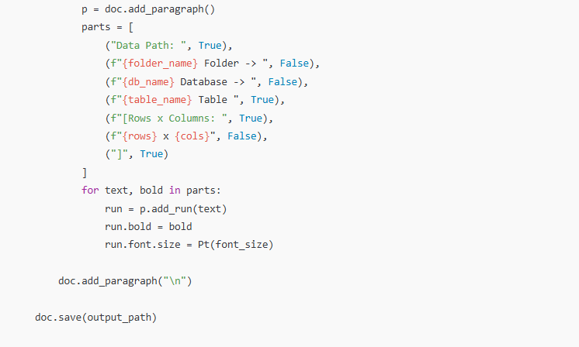
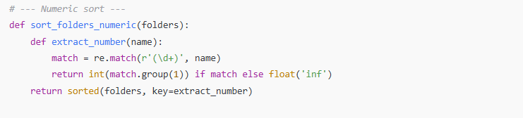
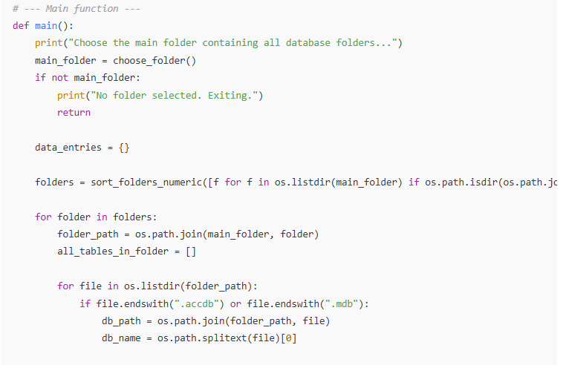
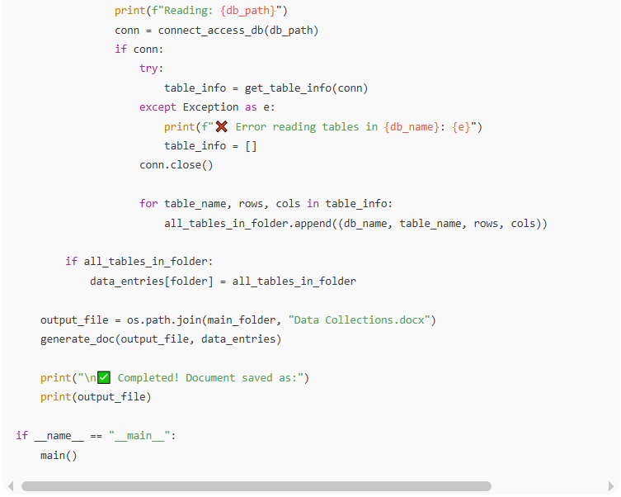
import os
import re
import pyodbc
from docx import Document
from docx.shared import Pt
from tkinter import Tk, filedialog, simpledialog

# --- Folder selection ---
def choose_folder():
Tk().withdraw()
folder_path = filedialog.askdirectory(title="Select Main Folder Containing Database Folders")
return folder_path

# --- Connect to Access DB with optional password ---
def connect_access_db(db_path):
while True:
try:
conn_str = (
r"DRIVER={Microsoft Access Driver (*.mdb, *.accdb)};"
f"DBQ={db_path};"
)
conn = pyodbc.connect(conn_str, autocommit=True)
return conn
except pyodbc.Error as e:
# Check if password required
error_msg = str(e)
if "Not a valid password" in error_msg:
# Ask for password via Tkinter popup
Tk().withdraw()
password = simpledialog.askstring(
"Database Password",
f"Enter password for database:\n{db_path}\nLeave blank to skip:",
show="*"
)
if not password:
print(f"Skipping {db_path} due to missing password.")
return None
try:
conn_str = (
r"DRIVER={Microsoft Access Driver (*.mdb, *.accdb)};"
f"DBQ={db_path};"
f"PWD={password};"
)
conn = pyodbc.connect(conn_str, autocommit=True)
return conn
except Exception as e2:
print(f"❌ Could not connect with password: {e2}")
# Loop again to ask password
else:
print(f"❌ Could not connect to {db_path}: {e}")
return None

# --- Get table names from DB ---
def get_table_names(cursor):
table_names = []

try:
cursor.execute(
"SELECT Name FROM MSysObjects "
"WHERE Type = 1 AND Flags = 0 AND Name NOT LIKE 'MSys%'"
)
table_names = [row[0] for row in cursor.fetchall()]
except:
pass

if not table_names:
try:
for row in cursor.tables(tableType='TABLE'):
name = row.table_name
if not name.startswith("MSys"):
table_names.append(name)
except:
pass

filtered = []
for name in table_names:
if name.startswith("~TMP") or "TMPCLP" in name.upper():
continue
filtered.append(name)

return filtered

# --- Get table info ---
def get_table_info(connection):
cursor = connection.cursor()
tables = []

table_names = get_table_names(cursor)

for table_name in table_names:
try:
row_count = cursor.execute(f"SELECT COUNT(*) FROM [{table_name}]").fetchone()[0]
except:
row_count = 0

try:
cursor.execute(f"SELECT * FROM [{table_name}] WHERE 1=0")
col_count = len(cursor.description)
except:
col_count = 0

tables.append((table_name, row_count, col_count))

return tables

# --- Shorten long names ---
def shorten_name(name, max_length):
if len(name) <= max_length:
return name
part_len = max_length // 2 - 2
return name[:part_len] + "..." + name[-part_len:]

# --- Generate Word document ---
def generate_doc(output_path, data_entries):
doc = Document()

# Main heading
doc.add_heading("Data Collections", level=1)

# Calculate totals
total_tables = total_rows = total_cols = 0
for folder_tables in data_entries.values():
for _, _, rows, cols in folder_tables:
total_tables += 1
total_rows += rows
total_cols += cols

# Summary
summary_lines = [
f"Total Tables: {total_tables}",
f"Total Rows: {total_rows}",
f"Total Columns: {total_cols}"
]
for line in summary_lines:
p = doc.add_paragraph(line)
p.bold = True

doc.add_paragraph("\n")

# Folder-wise details
for folder_name, folder_tables in data_entries.items():
doc.add_heading(f"{folder_name}", level=2)

for db_name, table_name, rows, cols in folder_tables:
full_text = (
f"Data Path: {folder_name} Folder -> {db_name} Database -> "
f"{table_name} Table [Rows x Columns: {rows} x {cols}]"
)

# Adjust font size
if len(full_text) >= 116:
font_size = 7
elif len(full_text) >= 104:
font_size = 8
elif len(full_text) >= 96:
font_size = 9
else:
font_size = 10

p = doc.add_paragraph()
parts = [
("Data Path: ", True),
(f"{folder_name} Folder -> ", False),
(f"{db_name} Database -> ", False),
(f"{table_name} Table ", True),
(f"[Rows x Columns: ", True),
(f"{rows} x {cols}", False),
("]", True)
]
for text, bold in parts:
run = p.add_run(text)
run.bold = bold
run.font.size = Pt(font_size)

doc.add_paragraph("\n")

doc.save(output_path)

# --- Numeric sort ---
def sort_folders_numeric(folders):
def extract_number(name):
match = re.match(r'(\d+)', name)
return int(match.group(1)) if match else float('inf')
return sorted(folders, key=extract_number)

# --- Main function ---
def main():
print("Choose the main folder containing all database folders...")
main_folder = choose_folder()
if not main_folder:
print("No folder selected. Exiting.")
return

data_entries = {}

folders = sort_folders_numeric([f for f in os.listdir(main_folder) if os.path.isdir(os.path.join(main_folder, f))])

for folder in folders:
folder_path = os.path.join(main_folder, folder)
all_tables_in_folder = []

for file in os.listdir(folder_path):
if file.endswith(".accdb") or file.endswith(".mdb"):
db_path = os.path.join(folder_path, file)
db_name = os.path.splitext(file)[0]

print(f"Reading: {db_path}")
conn = connect_access_db(db_path)
if conn:
try:
table_info = get_table_info(conn)
except Exception as e:
print(f"❌ Error reading tables in {db_name}: {e}")
table_info = []
conn.close()

for table_name, rows, cols in table_info:
all_tables_in_folder.append((db_name, table_name, rows, cols))

if all_tables_in_folder:
data_entries[folder] = all_tables_in_folder

output_file = os.path.join(main_folder, "Data Collections.docx")
generate_doc(output_file, data_entries)

print("\n✅ Completed! Document saved as:")
print(output_file)

if __name__ == "__main__":
main()

This code assumes you have:
- pyodbc installed: pip install pyodbc
- python-docx installed: pip install python-docx
- Microsoft Access driver installed on Windows.

